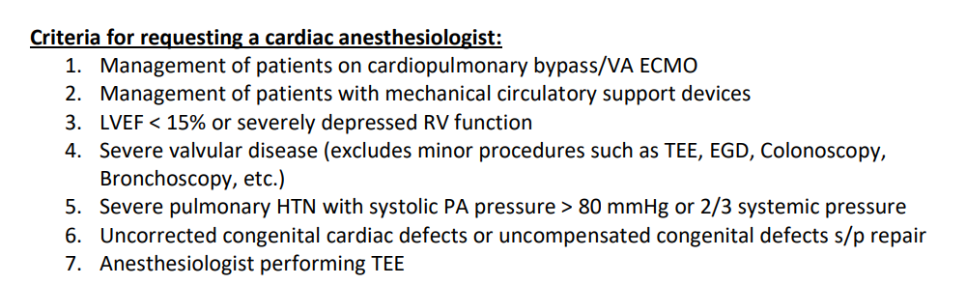
For any concerns regarding these criteria or the need for a cardiac anesthesiologist, Dr. Gerlach or Dr. Harrison should be contacted:
Dr. Brent Gerlach, Valley (Envision) Anesthesia Site Director:
219-689-0659 (cell)

Dr. Michele Harrison, Valley (Envision) Anesthesia Medical Director (Phoenix area):
623-755-4648 (cell)

Current as of 20 October 2025

