Perioperative Management Guideline for Patients taking Sodium-Glucose Cotransporter-2 inhibitors (SGLT-2) Drugs
11 December 2025

Purpose:
To provide standardized recommendations for the safe perioperative management of patients taking SGLT-2 inhibitors, including identification of high-risk scenarios, medication hold times, and prevention/early detection of euglycemic diabetic ketoacidosis (eDKA).

Scope:
Applies to all adult surgical patients on SGLT-2 drugs across all settings, including elective and emergency procedures.

Background:
SGLT-2 is expressed in the proximal tubule of the kidney and mediates reabsorption of glucose from the tubular lumen. In individuals without diabetes mellitus, the filtered glucose load is less than the maximal glucose transport capacity (∼180 g/day). SGLT-2 inhibitors block the reabsorption of filtered glucose from the tubular lumen and thereby promote the renal excretion of glucose.

Side effects of SGLT-2 drugs include:
- Urinary frequency
- UTI and pyelonephritis
- Fournier's gangrene (necrotizing fasciitis of the perineum)
- Dehydration/hypotension/acute kidney injury (AKI)
- Diabetic ketoacidosis (euglycemic: eDKA)

The most immediate and serious complication is eDKA. The following criteria can be used to diagnose eDKA:

Glucose < 200 mg/dL AND ketonemia (serum beta-hydroxybutyrate > 3.0 mmol/L) AND at least one of the following criteria:
- Arterial pH <. 7.3
- Serum bicarbonate < 18 mEq/L
- Anion gap > 10
Representative Drugs:
- Canaglifozin (InvokanaTM)
- Dapagliflozin (FarxigaTM)
- Empagliflozin (JardianceTM)
- Ertugliflozin (SteglatroTM)
- Bexagliflozin (BrenzavvyTM)

Hold Recommendation
To minimize the risk of eDKA perioperatively, the FDA recommends holding SGLT-2 drugs 3 days prior to the procedure (4 for ertugliflozin).

FDA guidance: https://www.fda.gov/drugs/drug-safety-and-availability/fda-revises-labels-sglt2-inhibitors-diabetes-include-warnings-about-too-much-acid-blood-and-serious

Elective surgery / procedure guidance:
The FDA guidance was released in 2022. Since that time, the risk for eDKA has become better understood. Elective cases can be evaluated on an individual basis. The anesthesia provider and surgeon should discuss the risks and benefits associated with proceeding. General guidance for lower risk procedures is provided here (see high risk for eDKA criteria below):
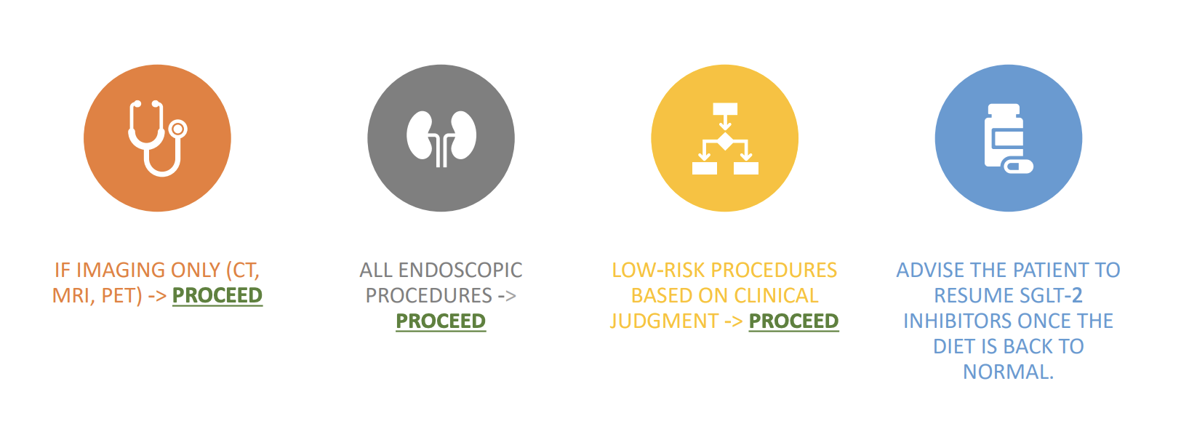

eDKA High-Risk Criteria:
- Type I DM
- Presumed NPO postop
- Diagnosis of Type I DM due to pancreatitis or pancreatic surgery
- History of DKA
- Preoperative HbA1C > 10%
- ASA Status > 3
- Excessive alcohol intake

Management:
For low-risk procedures in patients with diabetes mellitus and on SGLT-2 drugs:
- Check preop venous blood gas (VBG) and use the anion gap (AG) to guide management.
- If AG ≤ 12, proceed.
  - Re-check VBG Q1-2 hrs. during the procedure.
- If AG becomes >12, see guidance below.
  - If AG remains ≤ 12 during the procedure, check VBG in PACU/ICU and follow the DKA algorithm (see below).
- If AG > 12, postpone.
- If AG > 12 and serum bicarbonate ≤ 18, begin eDKA management (see below).
- If AG > 12 and serum bicarbonate is > 18, consider other causes of the anion gap.
  - In the PACU, if otherwise clinically stable, resume diet. Provide instructions on signs and symptoms of diabetic ketoacidosis upon discharge.

If AG > 12, check the serum bicarbonate. If the serum bicarbonate is ≤ 18:
- Check stat serum ketones (beta-hydroxybutyrate)
- Start standard insulin infusion protocol
- Start 5% dextrose fluid at 50 ml/hr if BG 150-250 mg/dl*
  - 10% dextrose fluid at 50 ml/hr if BG < 150 mg/dl*
- Monitor glucose checks Q1hr and VBG Q1-2hr while intra-op
- Once in PACU/ICU, transition to standard DKA protocol insulin infusion with glucose and VBG/ basic metabolic panel (BMP) monitoring per protocol until the anion gap closes
  - If serum ketones come back negative, consider alternative causes of anion gap acidosis, and discontinue insulin drip if clinically appropriate
  - Consult endocrine post-op: when the patient is admitted to the unit or the floor
  - If bicarbonate > 18, Consider alternative causes of anion gap, and continue checking VBG Q1-2 hr. Consider sending ketones or starting an insulin infusion if the etiology remains unclear

Urgent/Emergent Cases:
- Check stat VBG
- If AG > 12 follow the blue box above
- If AG ≤ 12 proceed with case and monitor VBG Q1-2 hrs
- if AG becomes > 12 then follow the blue box
- f AG remains < 12 during the procedure, continue to monitor postoperatively

DKA Management Summary:
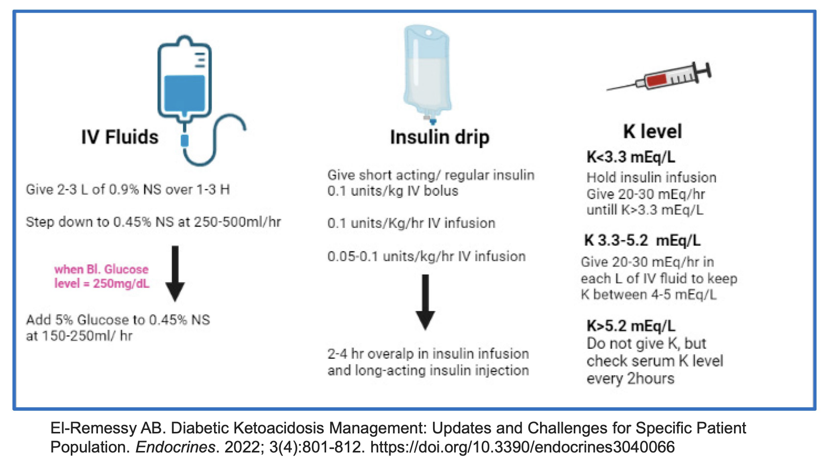

References:
- American Diabetes Association. 15. Diabetes Care in the Hospital: Standards of Medical Care in Diabetes-2021. Diabetes Care 2021; 44:S211.
- Handelsman Y, Henry RR, Bloomgarden ZT, et al. American Association of Clinical Endocrinologists and American College of Endocrinology position statement on the association of SGLT-2 inhibitors and diabetic ketoacidosis. Endocr Pract 2016; 22:753.
- Milder DA, Milder TY, Kam PCA. Sodium-glucose co-transporter type-2 inhibitors: pharmacology and peri-operative considerations. Anaesthesia 2018; 73:1008.
- Raiten JM, Morlok A, D'Ambrosia S, et al. Perioperative Management of Patients Receiving Sodium-Glucose Cotransporter 2 Inhibitors: Development of a Clinical Guideline at a Large Academic Medical Center. J Cardiothorac Vasc Anesth 2024; 38:57.
- El-Boghdadly K, Dhesi J, Fabb P, et al. Elective peri-operative management of adults taking glucagon-like peptide-1 receptor agonists, glucose-dependent insulinotropic peptide agonists and sodium-glucose cotransporter-2 inhibitors: a multidisciplinary consensus statement: A consensus statement from the Association of Anaesthetists, Association of British Clinical Diabetologists, British Obesity and Metabolic Surgery Society, Centre for Perioperative Care, Joint British Diabetes Societies for Inpatient Care, Royal College of Anaesthetists, Society for Obesity and Bariatric Anaesthesia and UK Clinical Pharmacy Association. Anaesthesia 2025; 80:412.
- Chacko B, Whitley M, Beckmann U, et al. Postoperative euglycaemic diabetic ketoacidosis associated with sodium-glucose cotransporter-2 inhibitors (gliflozins): a report of two cases and review of the literature. Anaesth Intensive Care 2018; 46:215.
- Steinhorn B, Wiener-Kronish J. Dose-dependent relationship between SGLT2 inhibitor hold time and risk for postoperative anion gap acidosis: a single-centre retrospective analysis. Br J Anaesth 2023; 131:682.
- Branco A, Fatima R, Liblik K, et al. Euglycemic Diabetic Ketoacidosis Associated With Sodium-Glucose Cotransporter-2 Inhibitors After Cardiac Surgery: A Review of Current Literature. J Cardiothorac Vasc Anesth 2022; 36:3877.

